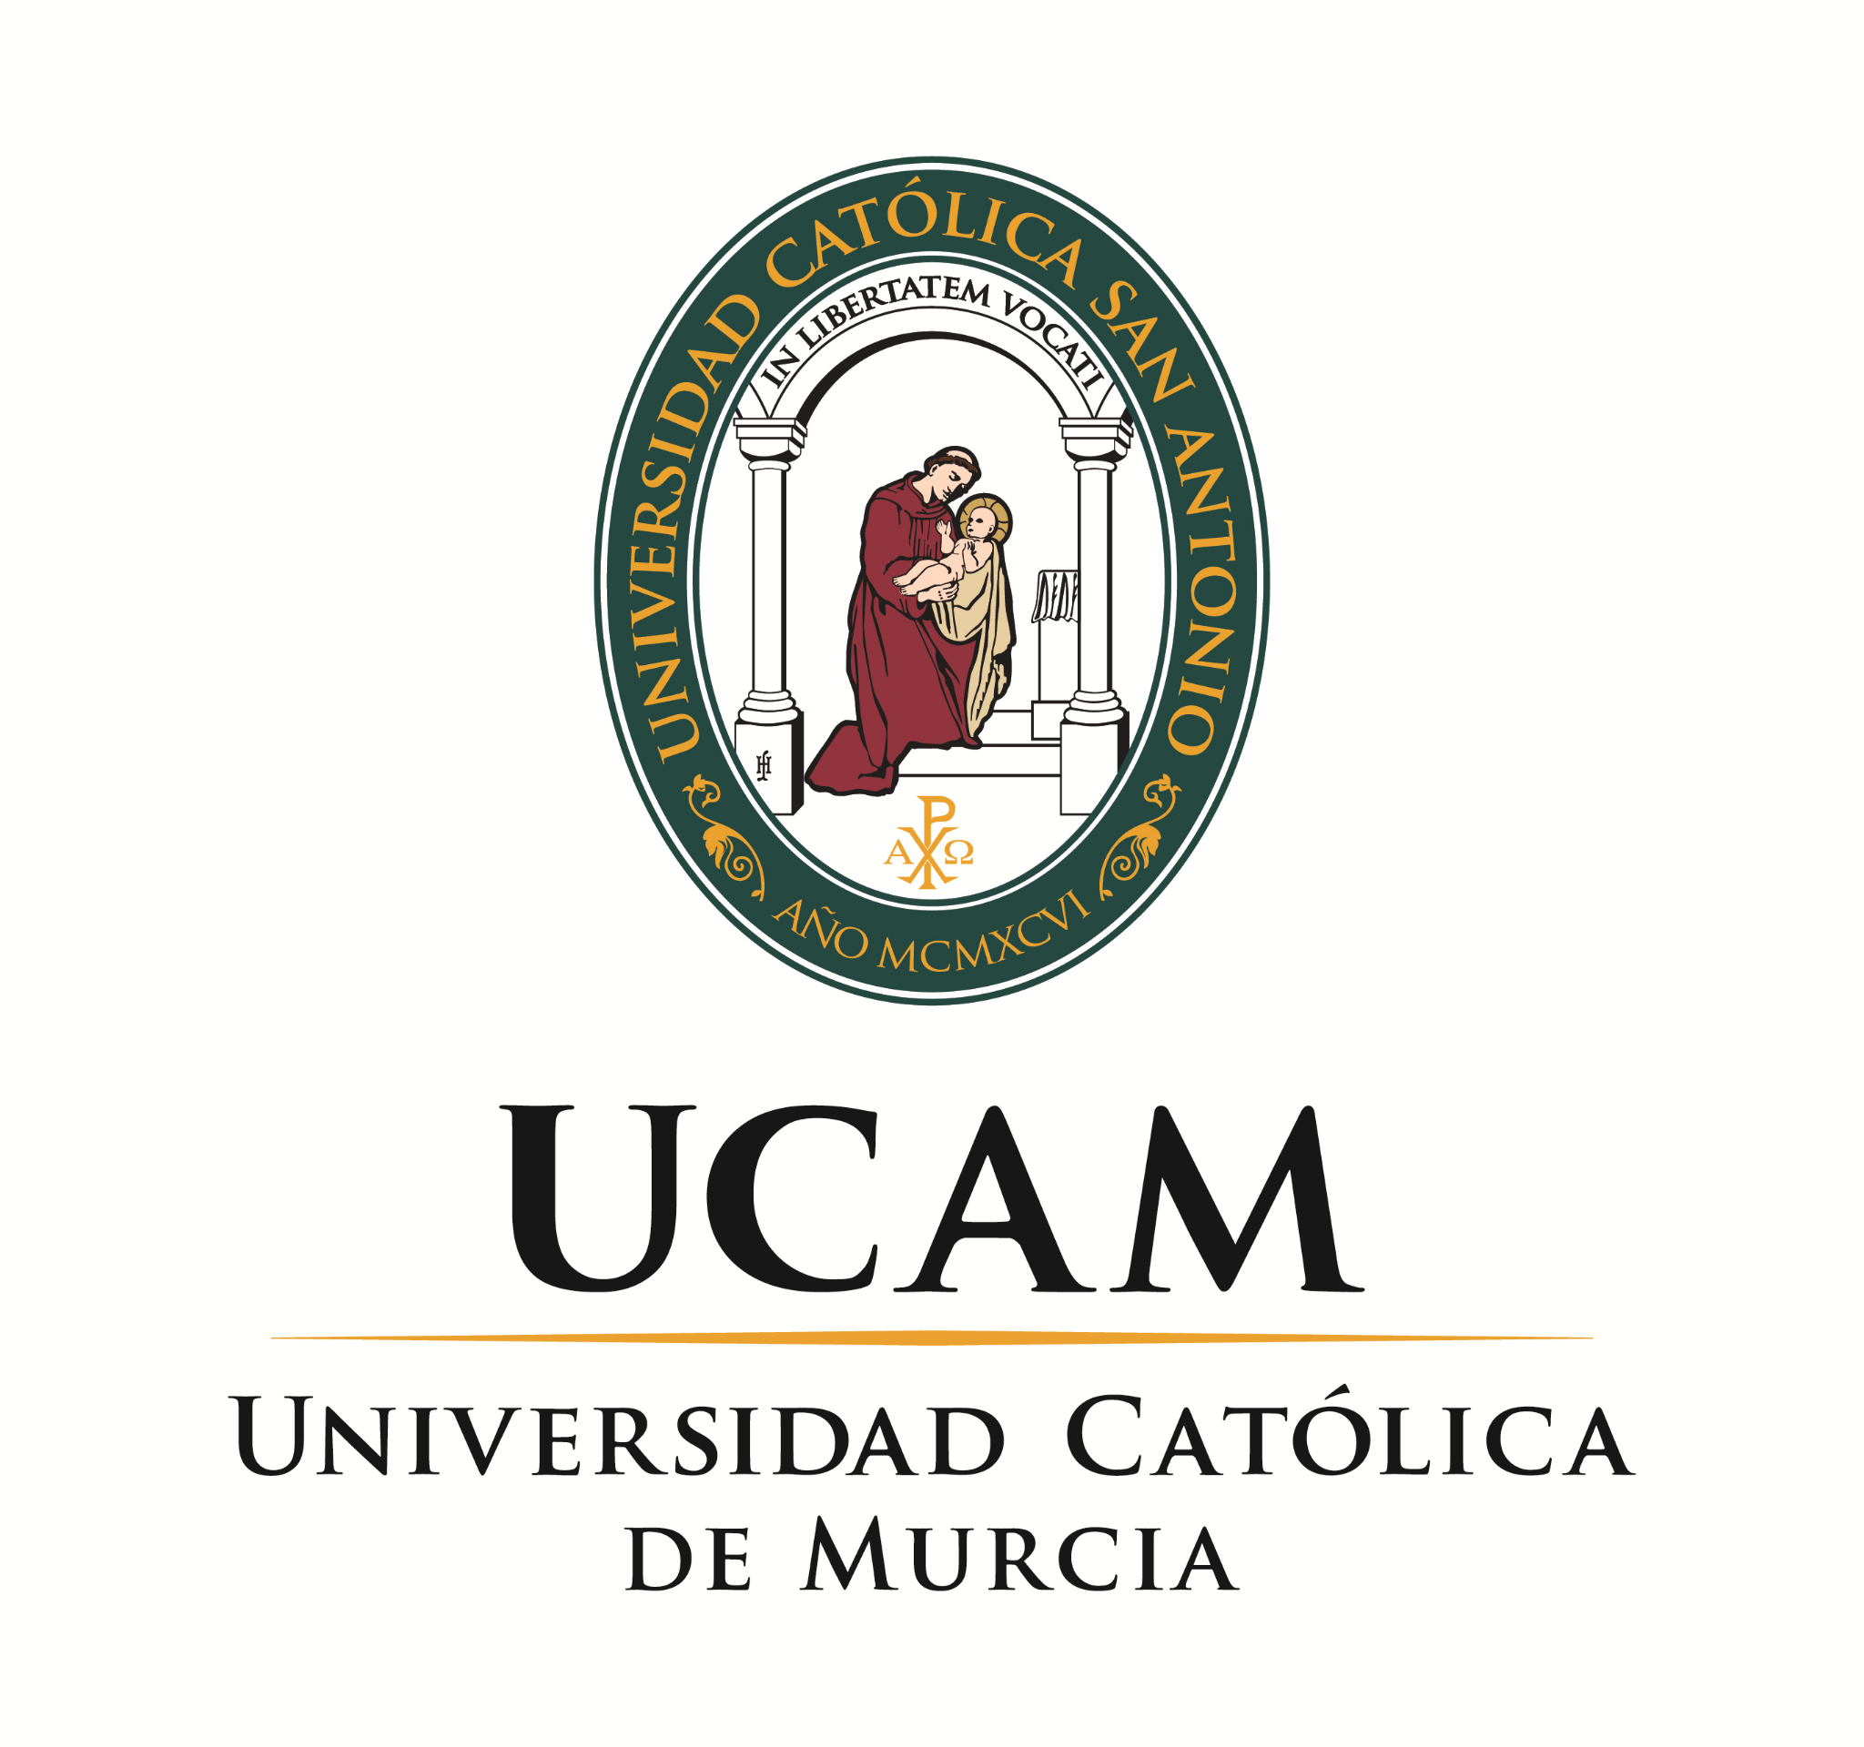

**Enhancement of internal quality assurance of education in teaching, learning and assessment in HEIs of Azerbaijan and Russia /IQAinAR**

**Work Package 2 - Development**

1. **INTRODUCTION AND GENERAL CHRONOLOGY**

WP2 aims to develop IQA indicators designed in WP1 taking into account the specificities of each university and the national background in teaching, learning, assessment and research. To this end, based on the indicators outlined as a result of the work carried out in WP1, the internal quality assurance methodology will continue to be developed for the two main areas : IQAs Methodology - STUDENT and IQAs Methodology - TEACHING STAFF / RESEARCH (Tasks 2.2 and 2.3), structuring the development and detail of the indicators around the three categories that group them together in WP1: TEACHING AND LEARNING, ASSESSMENTS and RESEARCH AND RESEARCHER.

Later, the developed IQA will be integrated and tested at institutional level (task 2.5) with a further discussion of first results with stakeholders and improvements made (task 2.4 and 2.6).

In addition, the partners will have the opportunity to conduct a study visit (Task 2.1) where P4 will present its IQA system and strategy, policy documents and become familiar with the institutional practice and its success factors.

The main objective of this work package is to enable consortium partners to **learn new methodologies for the improvement of their own IQA models, tools for self-analysis and models to help them imagine how to refine existing processes**. As a result of this learning, and with the intention of improving the common educational space and harmonizing it in compliance with the Bologna agreement, the consortium will develop an international IQA focused on student mobility and internalization of education, thus helping Russian and Azerbaijani HEI partners to improve student mobility programs, removing some of the existing obstacles in this area. The final product of this WP will be a User Guide documenting the methodology carried out for the development and design of these IQA indicators, as well as the didactic materials produced during WP2 (task 2.7).

[**GENERAL SCHEDULE**](https://docs.google.com/spreadsheets/d/1OKvRgJZvG0EOfWpLZl40CVaBcID-Rww2ocKE7WdH9u8/edit#gid=0)

| 2021 | | 2022 | | | | | | | | | | | |
| --- | --- | --- | --- | --- | --- | --- | --- | --- | --- | --- | --- | --- | --- |
| November | December | January | February | March | April | May | June | July | August | September | October | November | December |
|  | **Task 2.1** (ONLINE) |  |  |  |  |  | **Task 2.4** Moscou | **Task 2.4** Baku TBC |  | **Task 2.1** (FACE-TO-FACE) |  |  |  |
| **Task 2.2** and **Task 2.3** | | | | | | **Task 2.5** | | | | | | **Task 2.6** | **Task 2.7** |
|  | Virtual session - Best practices |  | | | | | | | | | | | |
| Review and submission of consensus indicator design templates | **Development of the indicators** established in WP 1, through the completion of templates agreed upon by the partners, organized in working groups by categories of indicators | | | **Review** and final **validation** of the templates for each indicator filled in by the partners | | Implementation of **pilot experience** in RU and AZ - implementation of indicators designed and developed. Collection and documentation of information and results of the indicators implemented. | | | | | | Analysis of  implementation **results** and feedback to other partners | |

1. **BREAKDOWN OF SPECIFIC TASKS AND DEADLINES**

WP2 has the following main objectives and tasks:

* **TASK 2.1** - Conduct a **study visit** to UCAM, focusing on IQA policy, indicators and practices developed at the institutional level with the participation of different stakeholders (e.g. students, professors, labor market, etc.) actively involved.

This task will be divided into two activities:

* + **Activity 1: Online meeting on December 14th, at 11.00 h.** Objective: Present best practices in quality assurance by UE partners and how the non-EU institutions can learn from these practices.

| ***Partner Responsible*** | ***Actions*** | ***Deadline*** |
| --- | --- | --- |
| **P1+P2+P3+P4+P5** | Confirm availability on the proposed date to celebrate a virtual session - EU partners meeting in the preparation of Task 2.1 | **DONE** |
| **P1+P2+P3+P4+P5** | EU partner experts - Virtual Sesión - Planning meeting of December 14th | **11/11/21** |
| **P4** | Confirmation of areas considered "core" by NON-EU partners in the implementation of an IQAS. These "core" areas will be the object of special attention in the presentation of "Best Practices" made by the EU partners in the virtual Study-visit. | **22/11/21** |
| **P4** | Send agenda and full instructions for interventions to all members, to celebrate the meeting of December 14th | **25/11/21** |
| **All** | Celebrate the virtual meeting | **14/12/21** |

* + **Activity 2: Study visit to UCAM in July 2022.** In this study visit partners will be able to learn about the IQA policy, indicators and practices developed at UCAM, at institutional level with the participation of different actors (e.g. students, professors, labor market, etc.)

| ***Partner Responsible*** | ***Actions*** | ***Deadline*** |
| --- | --- | --- |
| **P4** | Planning and delivery of visit agenda | **20/01/22** |
| **P4** | Referral to partners for validation | **01/02/22** |

* **TASKS 2.2 & 2.3** - Develop a **theoretical model of IQAS**, which will be measured by the list of indicators outlined as a result of the work done in WP1.

This task will be divided into 3 activities:

* + **Act. 1:** Define and detail the worksheet to develop each indicator, disaggregating and completing the integral elements of the designed indicator.

| ***Partner Responsible*** | ***Actions*** | ***Deadline*** |
| --- | --- | --- |
| **P4** | Send full instructions and proposed **template** | **4/11/21** |
| **All** | Comments and suggestions, through comments in the margins of the shared documents - Document "R-INDICATOR SHEET", | **10/11/21** |
| **P4** | Send definitive template | **15/11/21** |

* + **Act. 2:** Development of each indicator.

| ***Partner Responsible*** | ***Actions*** | ***Deadline*** |
| --- | --- | --- |
| **All** | Composition of the working group - Completion of the shared document | **5/11/2021** |
| **P4** | Full instructions and assignment of partners to each working group. Assignment to each working group of a pilot indicator to be developed, from those included in the list of WP1 indicators | **10/11/2021** |
| **Each Team** | Delivery of the developed pilot indicator | **26/11/21** |
| **All** | Virtual meeting to share and resolve possible doubts about the previous point | **30/11/21** |
| **P4** | Biweekly follow-up of the autonomous work developed by each team - by email | **biweekly from 30/11 to 25/02** |
| **Each Team** |  | **25/02/22** |

* + **Act. 3**: Cross **Review**

| ***Partner Responsible*** | ***Actions*** | ***Deadline*** |
| --- | --- | --- |
| **P4** | Send full instructions | **01/03/22** |
| **Each Team** | Review the indicators developed and detailed in act. 2 by another of the working groups and send comments on them | **20/04/22** |
| **P4** | Collect all information and generate final indicator document and model evaluation table | **06/05/22** |

* **TASK 2.4** - Develop **workshops in Moscow (RU) and Baku (AZ)**, with the objective of presenting IQA strategies and practices by project members and initiating a broad discussion within the academic community, society, government agencies and other stakeholders. The workshops will be organized by P-10 at the University facilities.
  + **Act. 1:** Preparation and deliver of **workshop agenda** by AZ and RU partners

| ***Partner Responsible*** | ***Actions*** | ***Deadline*** |
| --- | --- | --- |
| **TBD (supported by P4)** | Prepare the agenda for the workshop in Moscow | **20/12/21 (TBC)** |
| **P10 (supported by P4)** | Prepare the agenda for the workshop in Baku | **20/02/22 ( TBC)** |

* + **Act. 2:**  Referral to the consortium for **validation**:

| ***Partner Responsible*** | ***Actions*** | ***Deadline*** |
| --- | --- | --- |
| **TBD (supported by P4)** | Moscow | **05/01/22 (TBC)** |
| **P10 (supported by P4)** | Baku | **01/03/22 ( TBC)** |

* + **Act. 3:**  Develop **workshops in Moscow (UK) and Baku (AZ):**

| ***Partner Responsible*** | ***Actions*** | ***Deadline*** |
| --- | --- | --- |
| **P5 (supported by P4)** | Moscow | **MARCH 2022 (TBC)** |
| **P10 (supported by P4)** | Baku | **MAY 2022 ( TBC)** |

* **TASK 2.5 -** Implement the theoretical IQAS model designed in tasks 2.2 and 2.3 in RU and AZ partner institutions through a **pilot experience**.

| ***Partner Responsible*** | ***Actions*** | ***Deadline*** |
| --- | --- | --- |
| **P4 and non-EU partners** | Agree on the concrete indicators to be measured by each Ru and Az institution. The agreement will be reached by the partners through a joint working session, in which the possibilities of piloting all or certain indicators will be assessed according to the academic planning foreseen in the UK and AZ institutions for the months devoted to task 2.5 in WP2. One or several planning sessions may be held for the piloting to be developed in this task. | **29/04/22** |
| **P4** | Send instructions for the final report of the piloting phase. At the end of the piloting phase, the RU and Az partners will prepare a report on the experience, including the indicators actually implemented and the results of this implementation. These reports will then be presented in the next task of the package (task 2.6) | **30/05/22** |
| **non-EU partners** | Carry out the piloting phase by Ru and Az partners | **May-2022 to 20/10/22** |
| **non-EU partners** | Delivery of completed Task 2.5 reports by RU y AZ partners | **30/10/22** |

* **TASK 2.6 -** Following the development of the pilot experience, a webinar will be conducted through which the results of the pilot experience will be communicated by RU and AZ institution partners to all stakeholders to obtain their feedback and create general awareness on quality culture.

| ***Partner Responsible*** | ***Actions*** | ***Deadline*** |
| --- | --- | --- |
| **P4 +P9** | Webinar planning and agenda | **5/09/22** |
| **All** | Submission to partners for validation | **15/09/22** |
| **P4+P9** | Presentation of a model report to the partners, containing the work done by each partner in the development of WP2, including a section to fill in the conclusions that will be reached in the webinar to be held later in November | **15/10/22** |
| **ALL** | Celebrate the webinar | **5/11/22 (TBC)** |

* **TASK 2.7 -** Finally, the final product of this work package will be a user's guide that documents the methodology carried out for the development and design of these IQA indicators, as well as the didactic materials produced during work package 2 (task 2.7), and that will allow the elaboration of IQA systems in student mobility and internationalization education aspects.

| ***Partner Responsible*** | ***Actions*** | ***Deadline*** |
| --- | --- | --- |
| **P1+P2+P3+P5 +P6+P7+P8+P10** | Delivery of completed Task 2.6 reports by each partner | **20/11/22** |
| **P4+P9** | Development and delivery the final report to the partners, including a joint IQA system between the  project universities that will allow to enhance the quality of  student mobility programs, recongnition of learning outcomes  etc. | **20/12/22** |